The Preparing for Life Initiative (PfL):
a world-wide collaboration to reduce
maternal and child mortality and morbidity

Annual reports 2013 and 2014

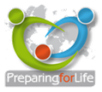

Leiden, The Netherlands
31 January 2015

Contact: | Preparing for Life  c/o TNO, Child Health  PO Box 3005  2301 DA Leiden  The Netherlands
 | Telephone: +31 888 661 883
 | Email: info@preparingforlife.net

Executive Summary

Introduction
The concept of the Preparing for Life Initiative (PfL) was conceived in 2007 with a number of dedicated and motivated individuals and organizations contributing to PfL activities. Constituent groups involved were Patient Alliances, Rotary Clubs and Academic groups and institutions.
The organization took a leap towards professionalization in 2013 with its establishment as a legal entity under Dutch law with a secretariat and dedicated secretarial staff time. This enabled the organization to position itself as a network organization with a wide representation of organizations interested in and promoting preconception care as a means of reducing maternal and newborn mortality and morbidity.
During the two year period, 2013-2014, Preparing for Life focused primarily on building and developing the organization by increasing capacity, mobilizing and extending networks, exploring opportunities and resources, and identifying options for further collaboration and support.

Governance and Operations
The Board met two times in the Netherlands during the two year period; 18 July 2013 and 3 October 2014, both meetings were held in the Netherlands. Throughout the period, the Board consisted of 10 persons.
The Executive Committee met 6 times in 2013 and 7 times in 2014. All meetings took place in the Netherlands. The number of Executive members increased from 6 to 8 in the period.
The Board and Executive Committee worked towards defining and operationalizing PfL working fields and harnessing expertise in the regions building a strong collaboration and working towards increasing visibility through networking and communications.
Besides the day-to day running of the organization, the Executive Committee worked on strategic planning, developed organizational policies and procedures, extended the organisation and wrote a number of proposals for funding.
The International Scientific Consortium met in November 2013 in the Philippines and in October 2014 in the Netherlands. Six new Consortium members were welcomed during the period and a vice-chair was installed in 2013.
The Consortium worked on developing a regional structure for more effective use of member’s expertise.
A PfL secretariat was established in 2013, hosted and supported by TNO (Netherlands Organization for Applied Scientific Research) in Leiden, The Netherlands. This was possible because of funding obtained through the Dutch Government. At the end of 2014, this funding was discontinued resulting in the ending of staff time support from TNO to PfL. Until a structural solution for a functioning secretariat is found, TNO and VSOP (as supporting stakeholder organizations) will continue to host meetings, maintain websites and provide logistical support.

Core Business
In the past two years, the organization took steps towards obtaining financial security for operations and to generate funds for actions. A proposal to the EU DG Sanco programme for an operating grant was submitted in 2013 and not honoured. The feedback will be used to submit a new proposal in 2015. Two proposals aimed towards regional activities in East Africa were developed but also not granted. Continued discussions with a charitable trust management group in the Netherlands will lead to a new proposal for East Africa regional activities in 2015. A funding inventory and analysis was undertaken in 2014 to be followed up in 2015 that guide activities aimed at raising funds.
In 2013-2014, there was significant investment in networking, dialogue and visibility. This resulted in membership in (inter)national platform organizations in the field of reproductive health. The website serving the PfL community was maintained and updated and a prototype website for the general public was developed. Informative and promotional flyers were produced and disseminated. PfL gave a number of national and international presentations introducing the initiative and engaging new stakeholders and interested organizations. Significant time investment also went to dialoguing and communicating with stakeholders and like-minded organizations both in the Netherlands and throughout the world. This enriched and strengthened the organization

Joint activities with constituency groups
Joint venture activities with constituent groups (patient alliances, Rotary and Zonta clubs and academic and scientific groups) and other relations resulted in a number of collaborative actions.
The collaboration between PfL and the pharmacy sector resulted in the development of a work programme scheduled for kick off in 2015. This programme, ‘Preparing for Pregnancy’ entails the establishment of mini Preparing for Life Information/Communication Centres in community pharmacies and is currently being piloted in the Netherlands. It is expected that this concept will also be appropriate in other parts of the world.
In 2013-2014, PfL interacted with service clubs. These interactions, primarily with Rotary and Zonta involved the promotion and incorporation of PfL activities in the work programmes of local clubs and the development of (demonstration) projects supported by local clubs. Examples of these are the Suriname project with funding from Rotary Leiden to initiate preconception care in order to reduce maternal and newborn mortality and morbidity and the Gambia project development by Zonta Leiden that carried out an assessment to develop a national multi-stakeholder meeting and local projects.
Significant investment went towards working with Rotary to develop a proposal for a Preparing for Life Rotarian Action Group. This involved a formal request supported by Rotarians from 17 countries and submission to the Board of Rotary International in 2014. A decision is expected in 2015.
Other interactions included discussions about a multi mass media campaign for awareness raising and fundraising (Rotary), collaboration with the Calmed (Collaborative Action in Lowering Maternity Encountered Death) project that includes a number of Rotary driven projects in North and West India and discussions at the governor’s level (Zonta) about options for providing formal support locally and worldwide.
PfL also worked closely with Patient Alliances exploring the possibilities and opportunities of collaboration with nutritional industry to be followed up in 2015 and for the development and inclusion of a special chapter on preconception and nutrition in a book on patient perspectives on nutrition.

Activities with the World Health Organization (WHO)

In 2013-2014, PfL communicated with WHO Headquarters in Geneva. Topics of these interactions included the process of establishing a formal relationship, regional and country level activities to implement preconception care, support and resources needed to facilitate regional and national capacity to plan, implement and monitor preconception care programmes and options for training and education at national level.
PfL also communicated with WHO regional offices. Topics of these interactions included planning for a pan European meeting and/or sub-regional conferences with EURO (European Region) and support for the organization regional stakeholders conferences/meetings and with the EMRO (East Mediterranean and Gulf States Region), with the AFRO (Sub Sahara Region) and with AMRO (Americas) regions.

Looking Forward
In the next two years, Preparing for Life will continue its work towards implementing the roadmap of actions as defined during the Geneva meetings in 2012. It will continue to increase its visibility in the global communities, maintaining relations and establishing new collaborations within the network and continue to develop and support implementation of PfL activities and (demonstration) projects locally, nationally and regionally.
The short-term need for a functioning secretariat with a dedicated Executive Secretary is a priority issue in 2015. Steps will be taken to find fill this gap through constituents as an immediate measure and to secure core funding as a longer term measure.

Table of Contents

Executive Summary i
Table of Contents v
Introduction 7
Activities overview 2013 and 2014 9
Governance and Operations 9
Core Business 10
Joint activities with constituency groups 11
Activities in cooperation with WHO 14
Looking Forward 16
Annex 1- Documents for reference 18
Annex 2- Board members 19
Annex 3- Executive Committee members 20
Annex 4- International Scientific Expert Consortium Members 21

Introduction

The start of the initiative
The concept of the Preparing for Life Initiative (PfL) was conceived in 2007 when the International Patient Alliance (based in Soest, The Netherlands) and the Rotary Club Baarn-Soest started exploring options for calling attention and promoting action for primary prevention measures resulting in healthier pregnancies, birth and children. In March 2010 a proposal for a worldwide policy and action plan on preconception care was submitted to an International Expert Forum who discussed the proposal and improved the plan. This meeting was organised by the Dutch Alliance of Patient Organisations (VSOP) and the Rotary Club Baarn – Soest , in collaboration with the Health Council of The Netherlands and held in the Dutch Ministry of Health in The Hague. This meeting resulted in the creation of a platform for action (PfL) aiming to work evidence based, top down (global, regional, national, local) as well as bottom up (local demonstration and feasibility projects), to collaborate with existing organizations and institutions active in one more of the PfL working fields and with a focus on awareness raising and resource mobilization. The Netherlands was asked to take the lead and function as initiator and motor for the Preparing for Life Initiative for the next few years.

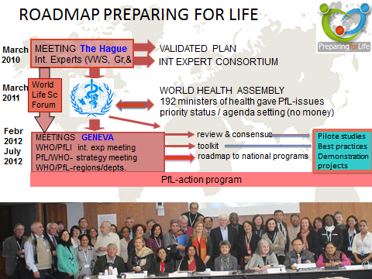
Preparing for Life grew as network organization increasing its number of contacts and experts. In 2011 PfL closely collaborated with WHO Headquarters in Geneva and other stakeholders as the US based March of Dimes to organize an International Expert Meeting on preconception care. This meeting took place in February 2012 in Geneva. During this meeting a consensus was reached regarding an evidence based, cost effective, package of interventions for implementation in existing primary healthcare services. In addition, specific working areas for preconception care were defined and described and a roadmap of actions for each area was formulated.
Following up on the WHO-expert meeting and in collaboration with WHO Headquarters, PfL organized, a second meeting focusing on implementation strategies. This meeting was attended by officers of relevant WHO departments. Also in 2012, a meeting took place in Geneva with PfL officials and officers from the WHO-regional offices where regional implementation of preconception care and country level approaches was discussed.

Organisation and Governance
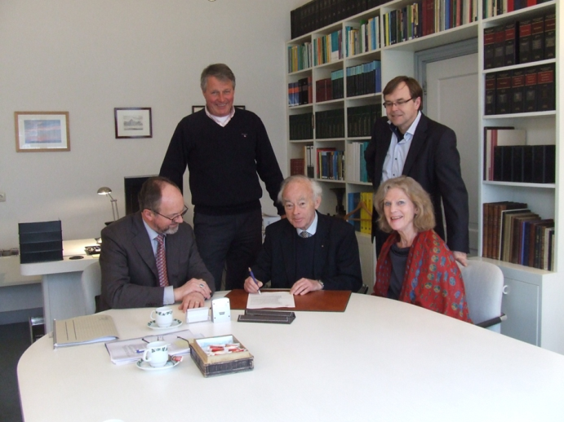
Preparing for Life is registered in the Netherlands and operates as a non-profit organization under Dutch law. The aim of the organization was documented as: ‘worldwide development, support and promotion of policies and activities leading to a reduction of infant mortality and morbidity and to safe motherhood and to enabling every women and couple at childbearing age to take free decisions on offspring well informed and in time’.
The organization is governed by a Board as determined in the articles of incorporation and bye-laws and meets annually. The Board has two officer positions: chair and secretary/treasurer.
Photo: Establishment of PfL as legal entity in 2013 , present are representatives from Rotary, Zonta and patient Alliances
The management and operations is carried out by the Executive Committee as determined by the bye-laws and supported by a secretariat. The Executive Committee meets 6-7 times a year.

Constituents
The Preparing for Life Initiative has three constituency groups:
- academic and scientific institutions
- patient alliances
- service clubs.
All groups have representation in the various PfL governing mechanisms and in the Consortium.

Working areas and fields of attention
The Preparing for Life Initiative distinguishes four main areas of action:
- Health- including genetic, chronic and infectious disease, over/under/potential harmful medication, obstetric risks and too early, unwanted, rapidly successive or too late pregnancies
- Nutrition- including over-and- under nutrition, nutrient and mineral deficiencies as folic acid etc.
- Lifestyle- including smoking, alcohol, substance use and hygiene
- Environment- including water and sanitation, social and economic factors, work and living conditions, exposure to radiation, pesticides and lead and mercury pollution
The priority mix of fields of attention for regions or countries need to be determined through needs assessments and integrated into existing primary healthcare service provision.

Activities overview 2013 and 2014

Over this two year period, Preparing for Life focused on building and developing the organization, increasing its capacity, mobilizing and extending networks, exploring opportunities and resources, and identifying options for further collaboration and support .

Governance and Operations
PfL Board
The Preparing for Life Board met on 18 July 2013 in Leiden, The Netherlands and on 3 October 2014 in Utrecht, The Netherlands. During this period, the Board consisted of 10 persons. A vacant Board position due to resignation of Prof. Eric Steegers in 2012 was filled by Prof. Jean Jacques Cassiman in 2013. A full list of the Board members can be found in annex 2.
PfL Executive Committee
The Executive Committee had 6 meetings in 2013 and 7 meetings in 2014. All meetings took place Leiden, The Netherlands. The Executive Committee expanded with two new members: Dr. Matty Crone in 2013 and Tanya de Vos van Steenwijk in 2014. A full list of Executive Committee members can be found in annex 3.
International Scientific Expert Consortium
The Consortium met in 2013 in on November 12th in Cebu, Philippines piggybacking on the 6th International Conference on Birth Defects and Disabilities in the Developing World. Due to the resignation of vice-chair Prof. Eric Steegers (who remained as Consortium member), Prof. Irmgard Nippert was appointed in his place to support the current chair Prof. Arnold Christianson. During this meeting 4 new Consortium members were welcomed: prof. Jai Rup Singh (Bathinda); prof. Ishwar Verma (Delhi); prof. Rumen Stefanov (Plovdiv); prof Ulf Kristoffersson (Lund).
In 2014, the Consortium met in Utrecht, The Netherlands. Part of this meeting took place as a combined meeting of the Board and Consortium. At this time, two new Consortium members were approved and welcomed: Prof. Ann-Mari Brubakk (Trondheim) and prof. Margot van de Bor (Amsterdam). A full list of Consortium members can be found in annex 4.
Secretariat
Through support provided by TNO (Netherlands Organization for Applied Scientific Research) in Leiden, an institutional secretariat was established in 2013. The support included staff time for an executive secretary, the hosting of meetings, logistic support, the establishment of archives (digital and hard copy) and financial support for PfL activities and travel.
After negotiations with the Dutch government at the end of 2014, it became apparent that there would be no continuation of the funding in 2015 and TNO secretariat support for staff time was stopped. In 2015, TNO will continue to host meetings and provide logistic support until a more structural solution has been found.
Besides the support from TNO, VSOP contributed to hosting meetings and maintaining the PfL website.

Summary of issues, actions and decisions
The Executive Committee and Board worked towards initiating action to harness expertise in the various regions, defining and operationalizing the various working fields, advising the Preparing for Life collaboration in the development of programmes and networking and communication with Ministries of Health, like minded academic groups and other involved stakeholders.
Besides the day to day operations, the Executive Committee worked on internal policies and procedures for the organization, strategic planning and developed and submitted a number of proposals for funding.
The Consortium has worked on developing a regional structure for more effective use of member’s expertise.

Core Business
As networking organization, PfL relies on its constituents to achieve the objectives of the initiative. Constituents represented in PfL governing bodies have been beneficial for PfL in the past two years providing advice and contributing to the day-to-day running of the organization.
Securing funding for operations and actions
- An operating grant application was submitted to the EU DG Sanco program in 2013. The application was rejected and an updated and improved application will be submitted in 2015
- There was communication with the Charitable Trust Management group in Dordrecht, the Netherlands that did not lead to a grant application but provided good information to use in the future. In 2015 a grant application will be submitted for activities in the East Africa region
- A small grants application was submitted to the Dutch Knowledge Platform Sexual & Reproductive Health & Rights (SRHR) for East Africa activities but was not granted.
- An inventory was made of funding options which will be followed up in 2015
- Course on friend raising offered free of costs by Gilissen, Wealth Management was attended by 2 PfL Executive Committee members

Networking, dialogue and visibility
- Production of a prototype website for general public in addition to an existing website serving the Preparing for Life community.
- Membership and participation in the Dutch Knowledge Platform Sexual & Reproductive Health & Rights (SRHR). This platform aims a.o. access to good-quality care to meet sexual and reproductive health needs and commodities.
- Membership organizational status in the Partnership for Maternal Newborn and Child Health (PMNCH) a global platform for knowledge, advocacy and accountability to improve women and children’s health.
- Communication was maintained with the Dutch Ministries of Health & Welfare, of Foreign Affairs and of Foreign Trade and Development Cooperation to structure collaboration on activities of mutual interest abroad and in the Netherlands.
- Several board members presented to Rotary clubs in the Netherlands to introduce Preparing for Life and stimulate collaboration
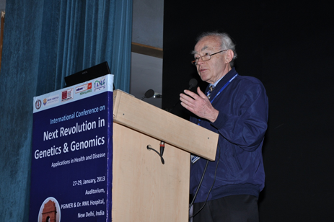
- PfL-chairman Ysbrand Poortman was invited to give a lecture on Preparing for Life issues at the international congress on “The next revolution in genetics and genomics, application in health and disease” in Delhi, in 2013
- An expert task group was formed for the EURO region and for the Eastern Mediterranean and Gulf-states to support the organisation of regional WHO/PfL meetings
Photo: PfL chair Ysbrand Poortman in Delhi, January 2013
- Preparation for formation of two task-groups; one on nutrition and one on genetics
- Communication on planning and streamlining policy and activities on an international level with:
  - International Clearinghouse for Birth Defects, Research and Surveillance (ICBDRS) in Rome Italy in April 2013
  - The Shell Foundation about the reduction indoor (kitchen) air pollution in the Hague, the Netherlands in June 2013
  - International Society for Rare Disorders (ICORD) in Ede, the Netherlands in October 2014
  - 1st Beijing University to establish a unit in Beijing for the International Genetic Alliance (IGA) and Preparing for Life as a major IGA project (various meetings )
- Communication on planning and streamlining policy and activities in The Netherlands with:
  - Netherlands Organisation for Health Research & Development (ZonMw)
  - Dutch Foundation for Preconception Care (SPN)
  - Dutch National Institute for Public health and the Environment (RIVM)
  - Several Dutch Universities and affiliated university hospitals in Leiden, Rotterdam, and Amsterdam
  - Health Council of The Netherlands
  - Dutch National Information Centre on Genetics (Erfocenter)
- A well-attended mini symposium was organized for volunteers, supporters and partners of Pf in Leiden in October 2014. The Consortium chairs presented, introducing the Preparing for Life Initiative and reporting on activities in the Middle East and South Africa
- Production of information flyers for dissemination and promotion activities.

Joint activities with constituency groups
Joint venture activities with constituents and like-minded relations resulted in collaborative actions (demonstration)projects. Below is a summary overview of these actions in 2013-2014 by type of constituent or collaborating organization. “Preparing for Pregnancy”: a collaboration with the Pharmacy sector, each pharmacy a mini Preparing for Life Information/Communication Centre
Community pharmacies form a permanent, professional, appreciated, easy accessible and effective point for proactively engaging women of childbearing age. A mini information Centre located in a community pharmacy can promote positive preconception care behavior as intake of folic acid supplementation, timely pharmacovigilance and an increase in awareness about the existence of and access to individual preconception consultation.
In 2012, Preparing for Life and the International Pharmaceutical (FIP) agreed on a collaboration in the domain of preconception care, in order to enhance active involvement of community pharmacies in the promotion of options for safe motherhood and healthy babies. Preparing for Life founded an expert support group. In collaboration with MediClara, a Dutch expert company on the subject and related to the VU University Medical Center, Amsterdam, a work programme was developed with a twofold objective: a direct contribution to reproductive health and good pregnancy outcomes in the Netherlands and a demonstration of the potential for the implementation of preconception care through the involvement of community pharmacies. An extensive implementation program was set up (training, promotional materials, info packages, engaging pharmacies, societal support, cost coverage issues, monitoring and reporting ).
Early 2015 the kickoff of “Preparing for Pregnancy” will take place in three small groups of pharmacies in the Netherlands, all led by Rotary pharmacists.
Out roll in the Netherlands is planned for the end of 2015 and possibly later in other European countries.
Ultimately any pharmacy, following the guidelines as set by the WHO/PfL expert meeting in Geneva and by the PfL-pharma group, should be able to operate as a Preparing for Life Information/Communication Centre.

General Activities with Service Clubs
Rotary :
- A significant amount of time investment went into developing a proposal for the establishment of a Preparing for Life Rotarian Action Group. This proposal with a formal request supported by 53 Rotarians from 17 countries was submitted to the Board of Rotary International (RI) in 2014. A decision is anticipated early in 2015. Potentially the 34.500+ Rotary Clubs worldwide, all having a commitment for service relating to Maternal & Child Health and Disease Prevention & Treatment, could be considered willing to serve the Preparing for Life objectives.
- Rotary Clubs in Baarn – Soest and Leiden are actively promoting Preparing for Life issues. Members of these clubs represent Rotary in the board, in the executive committee and in the expert consortium. Many other Rotarians from many other clubs showed their commitment and contributed in the one way or the other.
- Preparations (communication with experts in this field) are being made to submit grant applications to The Rotary Foundation
- Guidelines were developed and materials were produced to assist individual Rotary Clubs to take action in the field of awareness, promotion and fundraising in line with the Rotary focus areas “Maternal & Child Health” and “Disease Prevention & Treatment”. In this context a set up was made for a supportive PfL website. After try outs they will be promoted via the Preparing for Life websites
- The feasibility of a multi mass media campaign around the world for raising awareness and for fundraising was investigated and a preparatory meeting took place in Paris (7 June 2013). A manual for the organization was for a biannual event. A
- The Rotary Club Leiden raised funds for a Pre Conception Care - project in Suriname which was developed by Leiden University Medical Centre in collaboration with a Rotary Club and a hospital in Paramaribo, Suriname
- Following a meeting with Dr. Himansu Basu, past Rotary District Governor UK, in Amsterdam on 20 October 2014, it was agreed to collaborate with the India-based Calmed programme (Collaborative Action in Lowering Maternity Encountered Death). This includes various Rotary driven projects in North and West India focusing on “a reduction of maternal and new born mortality”
- On 13 December 2014 in Baarn, a meeting was organized to explore the role of Rotary for Preparing for Life actions. Fifteen present, past and incoming governors attended the meeting . Another 20 governors were not able to attend the meeting showed interest in participating in the follow up actions. It was agreed to start in The Netherlands by nominating district officers explicitly responsible for Preparing for Life actions.
Zonta:
- A discussion took place on governors’ level concerning the options for formal support locally and worldwide (advancement of the status of women worldwide, awareness building)
- Organization and sponsoring of the Gambia project. A first feasibility study/project was successfully held and paved the way for a national multi stakeholder meeting and local model projects. A report is available. Unfortunately the political situation did not allow continuation at this stage
- An attempt was made to develop a broker function between demonstration projects in India and elsewhere and Zonta clubs seeking projects. This will be continued in 2015
- A presentation was held for paediatricians and other interested medical professionals at Leiden University Hospital
- Various options were explored for setting up support groups to strengthen Preparing for Life in its executive activities (secretariat, legal affairs, promotion) were explored
- Meetings took place with the Dutch Director of Sinfa Uganda to explore options for collaboration for an interactive internet- course on preconception health for women in rural parts of North- Uganda
- The Zonta club Rotterdam provided organisational support for legal affairs through a and through a student intern for general assistance
- Invitational presentations to Zonta clubs Rotterdam I, Rotterdam a.d. Maas and Kennemerland to raise awareness and to facilitate their commitment
- Communication was established with the Department Funds & Foundations from Gilissen wealth management to explore options for funding.
Patient Alliances
- Adoption of PfL/WHO- roadmap in their policy and action programs was a subject of communication. This will be further defined in 2015
- The feasibility of a worldwide collaboration with nutritional industry on preparing for life issues was explored. Various meetings took place in Augst at DSM headquarters. This resulted in a charter of collaboration and streamlining of activities. Operational action is scheduled for mid-2015.
- Publication of the book Patient Perspectives on Nutrition with a special chapter on preconception and nutrition, produced in collaboration with the European Nutrition Health Alliance (EGAN/ENHA)

Overview of areas were PfL is active

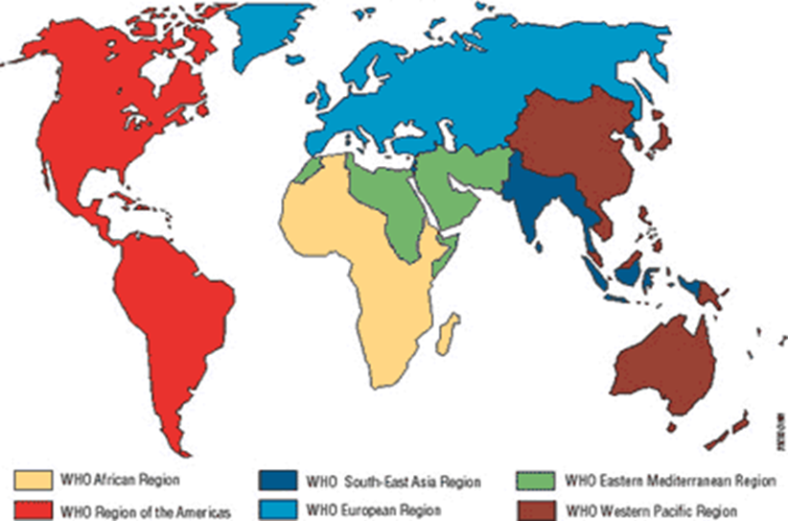
x

x

x

x

x

x

x

x

x

x

action in progress action in preparation

Activities in cooperation with WHO
World Health Organization (WHO) Headquarters Geneva
Following up on the 2012 International Scientific Expert Meeting in Geneva, several tele-meetings were held with WHO-Headquarters Geneva in 2013 and 2014. A major discussion issues was seeking support and resources for facilitating the regional and national capacity to plan and to implement and monitor preconception care programs.
Steps were also undertaken to establish a formal relationship with WHO for more visibility and positioning within the WHO governing bodies and events.
Other agenda items included:
- regional and country level activities on implementation of WHO report on Pre-Conception Care
- development of an advocacy document and exploration of the options for creating a digital PfL platform
- preparing a strategy for supporting and funding meetings, sensitizing regional and country level officers of WHO and PfL constituents, promoting demonstration and model projects
- exploring options for training and education at national level
- initiation and promotion of demonstration projects (in progress in Suriname, Oman, The Gambia, India, Tanzania)

World Health Organization (WHO) regions
Specific communication, actions and activities in the WHO regions included :
EURO (European Region):
- meetings and teleconferences with WHO-Europe in Copenhagen (10 January 2013) focusing on a pan European meeting on PfL. Efforts with the Ministry of Health of Italy to organize this meeting in Rome failed late in the planning due to the fall of the government. Currently there are discussions with Bulgaria about organizing this meeting
- extra attention was given to the interests of the South East European areas as the needs are most severe in these countries
- independent of the outcome of the Pan European Meeting, scheduled summer 2015), sub- regional conferences (SE Europe, Mediterranean Europe, W Europe) may be organized as a next step towards country level implementation of a package of interventions and measures
- development Action plan with activities regarding awareness, funding, nutrition, genetics (discussed in Berlin 8 May 2014)
EMRO (East Mediterranean and Gulf States Region:
- Continuation of in 2012 started conversation about the preparation of and support for a Pan-Arab conference with Dr. Anna Rajab in June 2013. A detailed proposal for the organization of a regional stakeholders conference was discussed and accepted and is scheduled for March 2015.
- Support Oman by increasing knowledge in the field of genetics by facilitating experts to train in the Netherlands and a Dutch expert to assist in Oman.
- Provided advice on request of the Minister of Health of Oman towards developing long term health policy
SEARO (South East Asia Region)
- A meeting with SEARO-leaders discussing needed action for the region. Preparing for Life is seeking support and resources for the organization of a regional meeting and for facilitating demonstration projects
AMRO (Americas Region)
- communication with Dr Matilde Maddaleno, dept. Adolescent Health and her team in Washington DC in September 2013 about organizing a regional multi-stakeholder meeting

Looking Forward

The short-term need of a functioning secretariat with a dedicated Executive Secretary has been prioritized as an important issue for 2015. Steps will be taken to find fill this gap through constituents as an immediate measure and to secure core funding as a longer term measure.

In the next two years, Preparing for Life will continue its work towards implementing the roadmap of actions as defined during the Geneva meetings in 2012. Regional/continental meetings are planned to define strategic, practical and program issues tailored to the needs, policy and culture of the regions. Regional meetings will be followed by national multi-stakeholder round table conferences in order to identify context specific needs, to mobilize existing expertise and capacity, both and to develop projects or tailor existing programmes to specific target groups to incorporate PfL concepts into existing primary healthcare services in collaboration with these services and communities .

PfL’s will continue to increase its visibility in the global community and to continue working with other motivated and like-minded organisations nationally as well as on the international level.

A major bottom up action has started in the Netherlands with a pilot project involving pharmacies serving as a mini PfL-service point for roll out later in the year.

Programs and actions in the field of genetics, nutrition and awareness are in the process of development.

The service organisation constituents Rotary and Zonta, and the patient alliances and the scientific groups are expected to increase substantially their input in Preparing for Life in the coming years.

-

Annex 1- Documents for reference

The following is a list of reports and documents developed by PfL or in collaboration with others.

WHO/PfL collaboration
- 2012: Expert Meeting, Geneva, 6-7 February http://www.who.int/maternal_child_adolescent/documents/concensus_preconception_care/en/
- 2012: PfL/WHO meeting on strategy development and implementation, Geneva, 8 February
- 2012: Meeting report , PfL with officials of the WHO regional advisors, Geneva, 4 July
- 2012: Report international round table conference in conjunction with 2nd European Conference
- on Preconception Care, Rotterdam, 5 October .
- 2013: WHO policy brief “Preconception Care: Maximizing the Gains for Maternal and Child Health”: http://www.who.int/maternal_child_adolescent/documents/preconception_care_policy_brief.pdf

Other documentation
- 2007: Preconception Care, a good beginning, Dutch Health Council
- 2014: Report mini symposium “Preparing for Life in 2014”, Leiden, 2 October 2014

Annex 2- Board members

PfL Board members on 31 December 2014
Name | Position | Affiliation |  | Country
Ysbrand Poortman | Chair |  | Rotary Club Baarn-Soest, International Genetic Alliance (IGA), | The Netherlands
Dr. Symone Detmar | Secretary/ Treasurer |  | Netherlands Organization for Applied Scientific Research (TNO), Leiden & Rotary, Leiden | The Netherlands
Prof. Jean-Jacques Cassiman | Member |  | Dept. of Human Genetics Catholic University of Louvain, Louvain | Belgium
Prof. Arnold Christianson | Member |  | Division Human Genetics, National Health Laboratory Service, University of Witwatersrand / Johannesburg | South Africa
Prof. Martina Cornel | Member |  | Free University, Depr. of Community Genetics and Public Health Genomics, Amsterdam | The Netherlands
Prof. Irmgard Nippert | Member |  | Women’s Health, Westfahlen University, Germany, Muenster | Germany
Dr Cor Oosterwijk | Member |  | European Genetic Alliances’ Network, EGAN, Brussels, Belgium & VSOP, Soest | The Netherlands
Prof. Jacques Scheres | Member |  | European Centre for Disease Prevention and Control / Rotary, Maastricht | The Netherlands
Prof. Pauline Verloove | Member |  | Netherlands Organisation for Applied Scientific Research (TNO) & Rotary, Leiden, | The Netherlands
Willem Barent Wijsmuller | Member |  | Rotary Club Baarn - Soest | The Netherlands

Annex 3- Executive Committee members

PfL Executive Committee members on 31 December 2014
Name | Affiliation | Country
Dr. Matty Crone | University of Leiden Medical Centre, Leiden, Rotary, Leiden | The Netherlands
Dr. Martina Ens | University of Leiden Medical Centre, Leiden, Zonta Leiden | The Netherlands
Dr. Symone Detmar | Netherlands Organization for Applied Scientific Research (TNO), Leiden & Rotary, Leiden | The Netherlands
Dineke Korfker | Netherlands Organisation for Applied Scientific Research (TNO), Leiden | The Netherlands
Dr. Cor Oosterwijk | European Genetic Alliances’ Network, EGAN, Brussels, Belgium & VSOP, Soest | The Netherlands
Ysbrand Poortman | Rotary Club Baarn-Soest, International Genetic Alliance (IGA), | The Netherlands
Prof. Pauline Verloove | Netherlands Organisation for Applied Scientific Research (TNO) & Rotary, Leiden, | The Netherlands
Tanja de Vos  van Steenwijk | Rotary Baarn/Soest, Baarn | The Netherlands

Annex 4- International Scientific Expert Consortium Members
Members on 31 December
Name | Affiliation | Country
Prof. Arnold Christianson  (co-chair)* | Division Human Genetics, University of Witwatersrand, World Alliance of Organisations for Prevention of Congenital Disorders (WAO) | Johannesburg, South Africa
Prof. Irmgard Nippert  (co-chair)* | Women’s Health, Westfahlen University, & WAO | Muenster, Germany
Prof. dr. M. van de Bor | Free University Medical Center (VUMC) | Amsterdam, The Netherlands
Prof. A. Brubakk | University of Trondheim | Trondheim, Norway
Dr. Coleen Boyle* | Centres of Disease Control and Prevention | Atlanta GA ,United Sates
Martha Carvalho | Brazilian Genetic Alliance of parent/patient organisations | Sao Paulo,Brazil
Prof. Martina Cornel | Free University, Dpt. of Comm. Genetics and Public Health Genomics | Amsterdam, The Netherlands
Dr Chris Howson | March of Dimes, Global Programs | New York NY, United States
Prof. Leo ten Kate | International Multidisciplinary Community Genetics Network | Amsterdam, The Netherlands
Alastair Kent* | International Genetic Alliance of parent and patient organisations IGA | London, United Kingdom
Prof. Ulf Kristoffersson | University and Regional Laboratories, Dept of Clinical Genetics, Lund University | Lund, Sweden
Prof. Pierpaolo Mastroiacovo | International Clearinghouse for Birth Defects Surveillance and Research | Rome, Italy
D.r Cor Oosterwijk* | European Genetic Alliances’ Network, EGAN, | Brussels, Belgium
Prof. Carmencita Padilla | University of the Philippines, Dep. of Pediatrics | Manila, the Philippines
Prof. Victor Penchaszadeh | Universidad Nacional de La Matanza, Dpt of Health Sciences | Buenos Aires, Argentina
Dr Anna Rajab | Genetic Centre /Ministry of Health | Muscat, Oman
Prof. Jacques Scheres* | European Centre for Disease Prevention and Control / Rotary, | Maastricht, The Netherlands
Prof. Jai Rup Singh | Central University of Punjab, Department of Human Genetics | Mohali, India
Prof. Eric Steegers | Erasmus University, Dpt. of Obstetrics and Gynaecology | Rotterdam, The Netherlands
Prof. Regine Steegers | Erasmus University, Dep. of Perinatal epidemiology | Rotterdam, The Netherlands
Rumen Stefanov Theunisse | Medical University of Plovdiv, Dept. of Social Medicine and Public Health | Plovdiv, Bulgaria
Prof. Pauline Verloove* | Netherlands Org. for Applied Scientific Research (TNO), Rotary Leiden | Leiden The Netherlands
Ishwar Verma | Sir Ganga Ram Hospital, Center of Medical Genetics | New Delhi, India
Prof. Peter Weber | DSM, Nutritional Products | Basel / Augst, Switzerland
Prof. Nanbert Zhong | Beijing University, Dept. of Med. Genetics, Peking University Health Science Center, | Beijing, China
* Consortium Executive Member

